Xfers, C2C Payment

More than PayPal of SEA, Xfers is focused on social media and escrow transfer (Sounds similar to our SeenPay model; however, why not create a partnership for LucLoi?)

Payments startups are coming out of the woodwork these days. As they seek to claim a place in the landscape crystallizing out of the volcanic material that is fintech, distinct formations are slowly starting to appear. Some companies want to upend the current system of payments by offering complete alternatives to existing banks. Some seek to provide solutions for the unbanked. And some are looking to streamline certain everyday transactions by taking advantage of existing infrastructure.

Singapore-based [Xfers](https://xfers.io/) is a part of the latter group. The startup enables C2C payments, aiming mainly at peer-to-peer transactions. These are usually buyers and sellers who use marketplaces like Carousell and Taobao or even social networks like Facebook and Instagram. For these users, payment options are usually limited to bank transfers. No one in their right mind would send their credit card information through a Facebook message (hopefully!), and cash is only an option when the buyer and the seller meet up… and that opens a whole different can of worms.

**To the Bay Area and back**

Xfers founders Victor Liew, Wenbin Tay, and Tianwei Liu wanted to tackle this area after experiencing first hand the difficulties of such transactions. The two NUS (National University of Singapore) graduates were working in Silicon Valley, at Quora and Amazon. Part of a large community of Singaporean engineers working in California’s Bay Area, they were frequently asked by friends back home for items that were easier to find in the US.

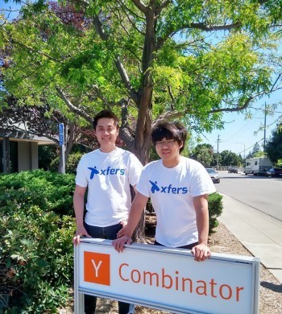

*(From L to R:) Xfers founders Tianwei Liu and Victor Liew*

But when payment time came along, there would be all sorts of problems. They’d have to chase people for payment, relay their bank account information, manually log in to their account every time to see if the payment came through, and manually keep track of who sent them what.

Like many a startup, Xfers was born after someone said, “There has to be a better way!”

**For us: There has to be a better way for C2C and even B2C marketplace for Vietnam, logistics and payment also. Logistics cross-border is a problem (Everyday, thousand flights take off, million of people travel from different places. Let’s those people who travel make extra money with the empty space in their luggage)**

Similar to their engineer friends, the duo often got together in their free time to code and hack – and play [Valve’s multiplayer PC game] Dota. “We’re a bunch of nerds anyway, so we hang out and do the same things all the time,” Liu quips. Xfers grew out of some coding sessions like that.

“Initially we decided on an API for banks, to sort of automate [the payment] process,” Liu tells *Tech in Asia*. “We got it done over a few weekends, and then we put it out, and it was pretty successful. A lot of our friends could use it easily – I just had to create a page and then they would just pay me and I would get notified.”

The company was founded in October 2014, and its product was initially an API for online merchants. “[Through it] we’re able to detect any bank transfer to our account within two minutes and then we integrate with shopping carts via API, to update inventory, to inform the merchants of the purchases made,” Liu says. “[It’s] pretty similar to what PayPal and Stripe do.” The company only works with bank transfers, and charges a flat fee of 45 cents for merchants to use its API.

**Click to pay**

But since Xfers began offering its services, the founders realized that their product could be ideal for peer-to-peer marketplaces such as Carousell, or people selling things through blogs and social networks. That’s why they added a new feature to their offering called Paylink, which is free to use.

Using Paylink, a seller can create a product listing, set a product picture and inventory, and generate a purchase link, which can be posted on the seller’s page. The buyer can then use that link as a check out button, regardless of where it is placed. Xfers processes the payment through its system and notifies the seller, and even holds on to the payment for a limited time, giving the buyer the opportunity to cry foul if they haven’t heard back from the seller.

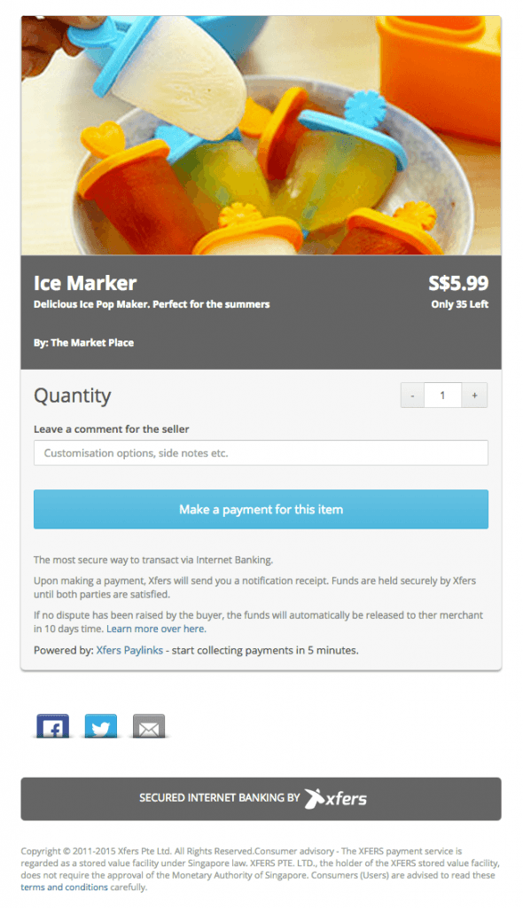

*An example of how a seller can generate a Paylink using Xfers’ interface.*

This, the founders say, gives sellers more control over who has paid *x*amount, and what they have sold to whom. It also eases buyers’ minds on whether the money they just transferred to a seller’s account will materialize in the purchased item or it will simply vanish in the electronic ether. “Right now if I want to buy something from another user, I will have to make a bank transfer to that seller’s account,” Liew says. “And once that happens, I’m not protected. I have to pretty much assume that the seller is trustworthy.”

Part of the user base the startup is going after consists of people who organize group purchases online from places like Taobao. “A lot of people organizing these group purchases share the shipping costs from China,” Liu explains. “What happens is they have people contributing by paying a deposit first.”

The problem with that method, he says, is that the group might not gather enough interested people to make the order be worth it, so it has to cancel. Whoever is organizing the group then has to refund everyone who contributed – by tracking down every transfer to his account and asking for the respective bank account details to send the money back. “It’s a real pain,” Liu concludes. Xfers’ solution allows for a one-click refund, where the system keeps track of who contributed what, and transfers the money back to each account.

**Working with the banks**

The system can currently work with bank accounts from 14 major financial institutions in Singapore. It is compliant with the country’s [FAST protocol](https://vimeo.com/88630761)(Fast And Secure Transfers, not to be confused with the FIX Adapted for STreaming protocol for TVs), which enables near-instant electronic money transfers between banks.

The founders feel their approach on leveraging bank account transfers and targeting C2C transactions can set them apart from other payment startups trying their own thing in the region. The question is, then, if there is enough of that customer base out there to allow the company to scale. It’s something Xfers will be finding out as it looks to expand to other markets beyond Singapore.

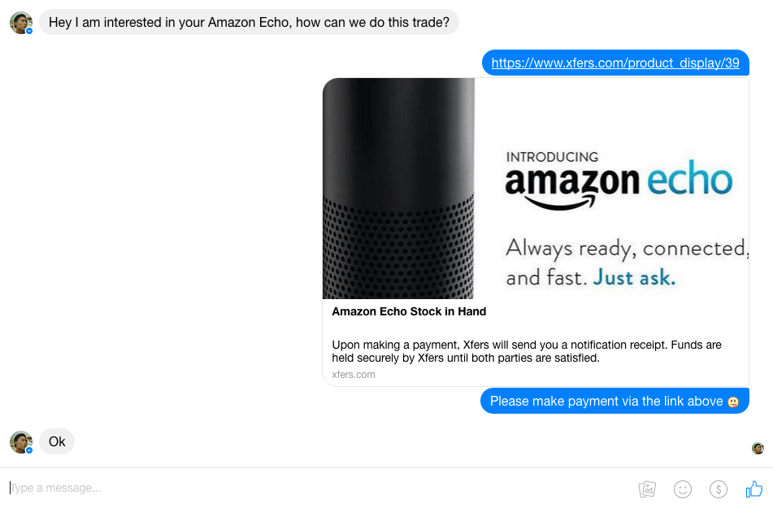

*The system allows buyers and sellers to transact even on social media.*

So far, the company says it has processed S$1.7 million (US$1.21 million) in transactions. It is in talks with some online marketplaces to integrate its API, and is about to graduate the current Y Combinator startup acceleration program. The founders both quit their full-time jobs to be able to attend, and now plan to return to Singapore and focus exclusively on Xfers.

“I think one of the key things we realized was that because we are engineers working in the Bay Area itself, we very used to APIs like Stripe and Braintree,” Liu says. “So when we first started, we thought everything we make has to be API-based. But after working very closely with the C2C market space, like Carousell and Taobao, we realized that for Southeast Asia and Singapore, we need a solution that’s customized for them. Giving the C2C sellers APIs is not going to work very well – and that’s where Paylink comes in.”